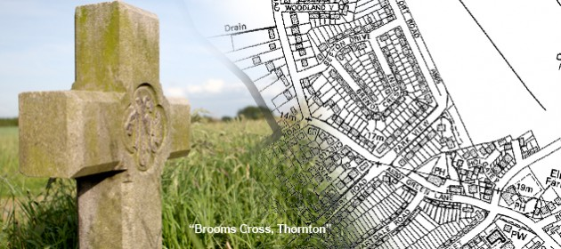
January 2017 Newsletter
Bring you up-to-date with regard to Thornton Parish Council and its plans for the future.

Visit our website:
www.thorntonpc.org.uk
Follow us on Twitter:

@ThorntonSefton

Follow us on Facebook:

Thornton Parish Council

Email us:

thorntonpc.clerk@googlemail.com

Thornton’s first Christmas Tree
It was great to see over 250 people (and one horse!) attend our first Christmas light switch on. Hopefully we can make this a yearly event. If you have any thoughts on this, please let us know.

Current Councillors in your area
Mrs J Jones (Parish Clerk)
Parish Councillor Ken Hounsell (Chair)
Parish Councillor David Leslie Miles
Parish Councillor George Pennington
Parish Councillor Robert Bain
Parish Councillor Mike Chambers

Proactive not Reactive
As a Parish Council we now believe that we can go forward on a proactive rather than a reactive basis and thus in time provide a better service for the residents of the Parish. Over the last year, we have spent time and money on developing our social media. It is now working well to keep everyone informed of local issues. Our Website is updated regularly with information about our area. We also use our Twitter account to deal with issues as they happen. Feedback from residents says this has increased our effectiveness.

What happens at a Parish meeting?
During our meetings we talk about local issues within Thornton. 20 minutes is set aside at each meeting for you to bring local issues to our attention. We also talk about areas we have been tackling and ways forward for our community. It is a chance for like minded locals to meet and work together on things that matter to us. Occasionally, we invite speakers to talk about certain issues. The meetings are for us all to work together as a community.

Why not follow us or even tweet your views or anything you think we should be aware of in the community.

@ThorntonSefton

Or join our group on Facebook : Thornton Parish Council

Annual Open Meeting
Many of you will recall that last year we introduced an Annual Open Meeting which was very well attended indeed. Our Open Meeting this year will take place on Thursday 9th February 2016, starting at 7.30pm at Holy Family High School. During this meeting we will have Members of Sefton Council delivering consultations on the following:
- Broom Cross Corridor Traffic Solution
We have all been affected by the Traffic Chaos since the new road was built. Sefton are ready to share the impact and offer us solutions to this.
- The Crescent Shopping Area
After many years, Sefton have now a way forward to improving our local shopping area.
These are you issues, please attend and make your voice heard!

What do you want?
We will be seeking your views on what YOU WANT from your local politicians be they Parish Councillors, Ward Councillors or indeed your Member of Parliament. We believe that the role of the Parish Council is changing and will become more and more important in the future in providing government from the bottom up rather than from the top down. This process is starting to happen but it will not happen overnight: we must be patient, we must work closely together and we must be determined to succeed in getting the best we can for our Parish.
Got a point of view? Something you want action on?

Email us: thorntonpc.clerk@googlemail.com

Focus for the year ahead
We are looking to focus on the lack of public amenities in Thornton to help build a community spirit in the area. We will be looking to local organisations to join us in this target. We want to build on our first Christmas Tree event and also the work we have started with local schools about our refurbished Stocks and Sundial.

Street light out? Fly tipping? Dog Fouling? Street Sweeping Complaint? Use Sefton Councils website to report it instantly. Tell us via Twitter and we will ensure it’s followed up.
2016 was big year for Thornton
What a year it was for our Parish last year! Here are some of the things we achieved together:
- Our First Christmas Tree
- Refurbishment of the Stocks and Sundial
- Tackling of Anti-Social behaviour within our Parish
- New Bus shelters on Southport Rd
- Better Signage around Thornton
- New bins around shops and school
- Working closer with residents on planning applications
For further information visit our website:
www.thorntonpc.org.uk

New Councillors Wanted!

We currently have two spaces for new parish councillors. Come along to our meetings and see if they are for you. Or get in touch with our clerk by email - thorntonpc.clerk@googlemail.com

Do you run a local community group?
If you run a local community group in Thornton and want more publicise, get in touch. We have happy to promote your club/group via our social media. We have a website, Twitter and Facebook page. Get in touch.
Thornton Parish Council
Calendar of Meetings 2017
- Monday 9th January 2017
- Monday 6th March 2017
- Monday 8th May 2017
- Monday 3rd July 2017
- Monday 4th September 2017
- Monday 6th November 2017
7pm at Holy Family School

