[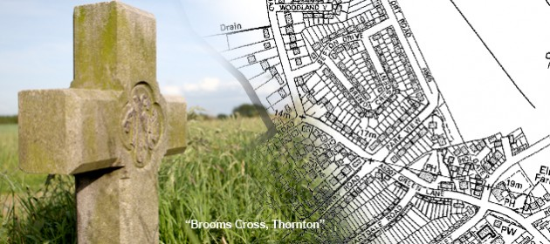](http://www.google.co.uk/url?sa=i&rct=j&q=&esrc=s&source=images&cd=&cad=rja&uact=8&ved=0ahUKEwig34LilITKAhVHMhoKHWf7BjoQjRwIBw&url=http://thorntonpc.org.uk/&psig=AFQjCNHB5HPuKnhG9hsT4Xmxy4c9lNbR-w&ust=1451584758214091)

**Thornton Parish Council**

**Newsletter**

Website: [www.thorntonpc.org.uk](http://www.thorntonpc.org.uk)

Twitter: [@ThorntonSefton](https://twitter.com/ThorntonSefton)

Email: thorntonpc.clerk@googlemail.com

**Holy Family Cancels Parish Meeting**

The Parish Council would like to apologise to those of you who attended Holy Family High School on Monday 11th January for our first meeting in 2016 only to find that it was cancelled because of circumstances beyond our control. Having agreed the dates of all of our meetings for the year, our Clerk received a message from the school during the afternoon of the day of the meeting to say that they had cancelled it. They have also cancelled our scheduled Open Meeting for the 1st February. This was in fact the third occasion when the school had cancelled scheduled meetings at short notice. We have arranged to meet with the school authorities in the near future to discuss the matter with a view to ensuring that this does not happen again.

**New Open Meeting Date**

On a more positive note we have re-scheduled the Open Meeting and that will now take place on Monday 8th February 2016 at Holy Family High School commencing at 7pm.

We hope to have members of Sefton Council to talk and answer questions on the impact of Brooms Cross Road and Flooding. A member of the local neighbourhood policing team will also be present and we have invited the Ward Councillors and our MP, Bill Esterson and members of the local clergy.

**Open Meeting 7pm**

**Monday 8th February**

**Holy Family High School**

[](http://www.bing.com/images/search?q=date+for+your+diary&view=detailv2&&id=9333F3C64FD32AE3D877F3A0964CBF9BBBC0B119&selectedIndex=7&ccid=8zabEun6&simid=608021594498009200&thid=OIP.Mf3369b12e9fa764b86c2a24475f87d7bo0)

**So far this year.......**

Following our meeting in January a number of matters were brought to our attention by residents who attended the meeting and as a result defective street lamps at The Crescent and in Brook Road were reported to the Street Lighting Section. Traffic Wardens will visit The Crescent and Virgins Lane to deal with complaints about indiscriminate parking and the police intend to enforce the 20mph speed limit on Ince Road. See merpol.sthsefton on ‘Twitter’

[](http://www.google.co.uk/url?sa=i&rct=j&q=&esrc=s&source=images&cd=&cad=rja&uact=8&ved=0ahUKEwjIsae4mYTKAhULiRoKHc9pDAYQjRwIBw&url=http://www.southernfriedscience.com/?p=12120&bvm=bv.110151844,d.d2s&psig=AFQjCNHEYnJJGRkXb_0rVzwdx4MM4UjRag&ust=1451585990127134)Why not follow us or even tweet your views or anything you think we should be aware of in the community.

[@ThorntonSefton](https://twitter.com/ThorntonSefton)

*Bringing you up-to-date with regard to Thornton Parish Council and its plans for the future.*



[](http://www.google.co.uk/url?sa=i&rct=j&q=&esrc=s&source=images&cd=&cad=rja&uact=8&ved=0ahUKEwjJrcL3noTKAhVBHBQKHbm-DM8QjRwIBw&url=http://www.radleygoodneighbours.org/&psig=AFQjCNF6cVTMlNwawca92WjVh13hB66nvA&ust=1451587447626081)

[](http://www.google.co.uk/url?sa=i&rct=j&q=&esrc=s&source=images&cd=&cad=rja&uact=8&ved=0ahUKEwiR6pXmnITKAhUHXRQKHX88CDgQjRwIBw&url=http://www.keepcalm-o-matic.co.uk/p/your-parish-needs-you/&psig=AFQjCNGnNtvdwZte1619PukJ3VnBnD3R4A&ust=1451586910712771)

**What do you want?**

We will be seeking your views on what **YOU WANT** from your local politicians be they Parish Councillors, Ward Councillors or indeed your Member of Parliament. We believe that the role of the Parish Council is changing and will become more and more important in the future in providing government from the bottom up rather than from the top down. This process is starting to happen but it will not happen overnight: we must be patient, we must work closely together and we must be determined to succeed in getting the best we can for our Parish.

**Meeting dates**

Monday 8th February 2016

Monday

All our meetings start at 7pm at Holy Family High School

**Our aim for the early part of 2016**

At our first meeting which we rearranged at short notice for Monday 18th January we identified four areas on which we wanted to concentrate initially in 2016 and they are as follows: Flooding, Street Cleansing, Traffic Issues and the provision of bus shelters especially for the new bus stops on Brooms Cross Road. We feel that we needed to set up discussions with Sefton MBC with regard to the four priorities set out above and if necessary ask members of the MBC to come and speak to you about those issues. There are many other issues which affect your daily lives which you might wish to bring to our attention so please do not hesitate to do so and we will take them on board.