[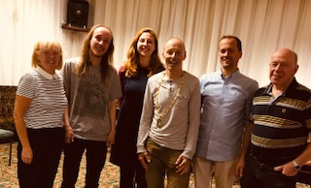](Newly%20elected%20Councillors%20&%20Clerk%20July%202019)